Create an EC2 and configure Apache web server on top of it.

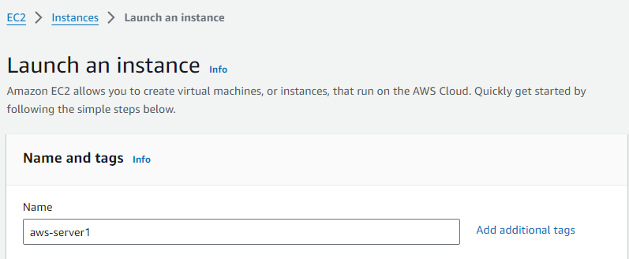

Make sure to select the Ubuntu 22.04 AMI. As we are going to use dependencies which are supported for this AMI only.

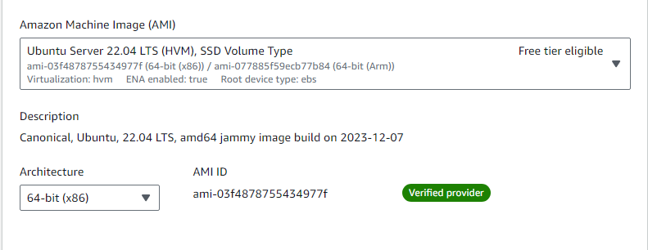

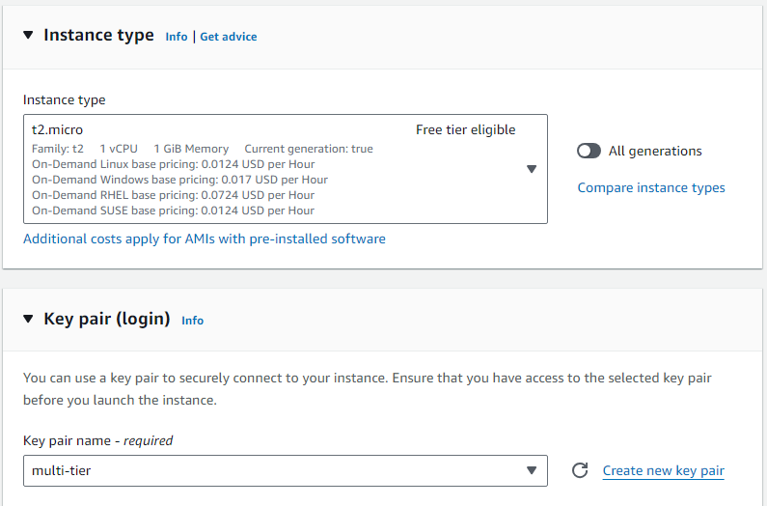

Now, In Network Settings, Click on Edit. Here we will configure rules for our EC2 Server.

Rules will allow SSH & HTTP Inbound Traffic from Source 0.0.0.0/0.

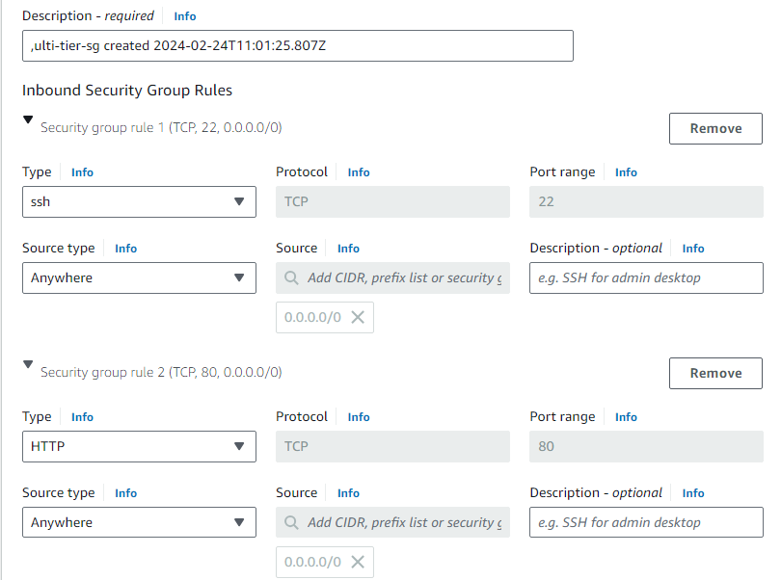

Launch the instance.

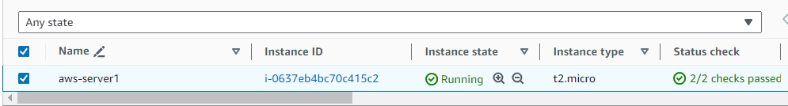

Now connect to the instance



To configure Apache, firstly lets update the machine and follow it up by installing Apache web server.

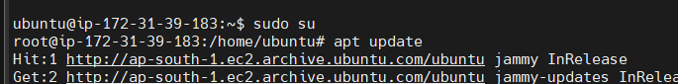

Install Apache web server using the below command:

*apt install apache2 -y*

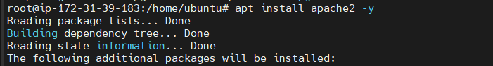

Go to the public IP of your EC2 machine, and you’ll see that the webserver is running.

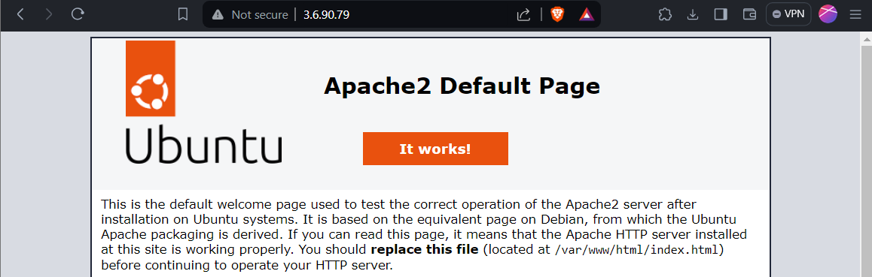

Now, we will replace the default Apache web page by content of our website. You can refer to the Github url below for website code.

<https://github.com/Raghavarora09/Multi-Tier-Website-using-EC2.git>

Clone the Github repo using the command below:

*git clone* [*https://github.com/Raghavarora09/Multi-Tier-Website-using-EC2.git*](https://github.com/Raghavarora09/Multi-Tier-Website-using-EC2.git)

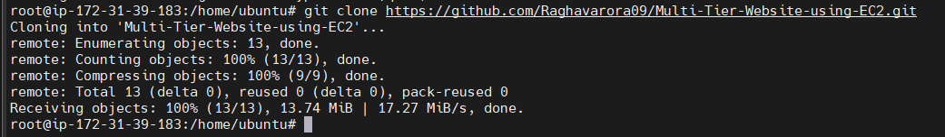

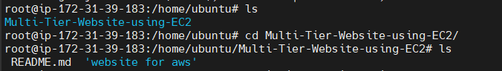

Copy the contents of ‘website for aws’ repository to /var/www/html repository (where the default page of apache webserver is present)

*cp -R website\ for\ aws/* /var/www/html*



Now, when you list the items inside the /var/www/html directory, you can notice index.html and index.php web pages. As index.html is the default Apache page, we don’t need it any longer as our main website is contained inside index.php.

To delete the index.html page, use the command below:

*rm /var/www/html/index.html*

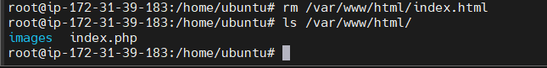

Index.html file is removed and now if you refresh the webpage in the browser, you should be able to see the php application.

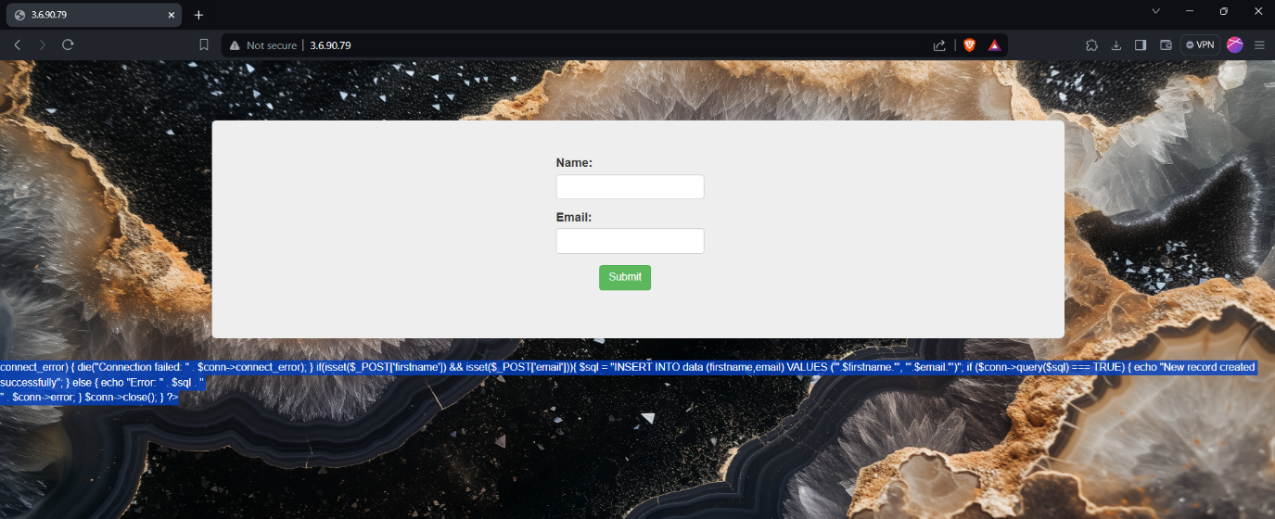

As you can see, our Php application is up and running.

In the console output, it gives Connection failed issue as we haven’t set up a database for this website yet. In the upcoming steps, we will configure an RDS Instance to fulfill the requirements.

Lets create a RDS MySQL database now. Choose the options as shown below.

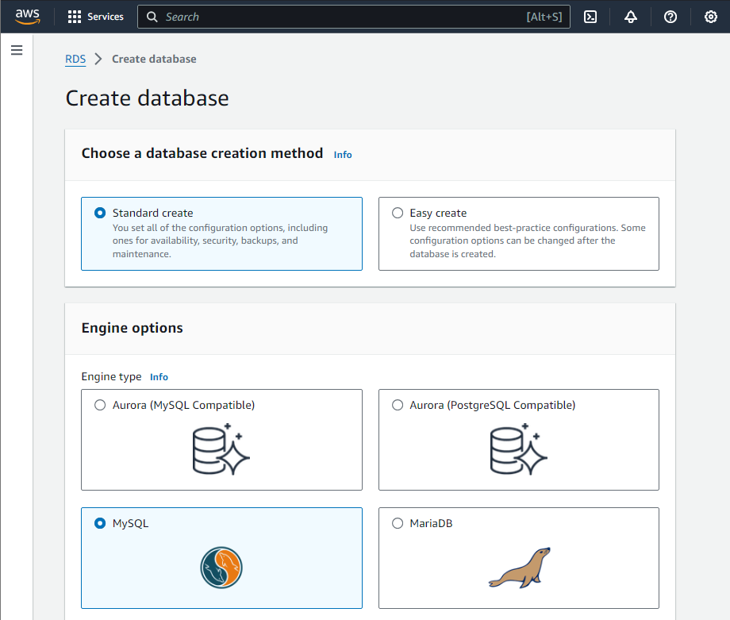

In templates choose Free Tier

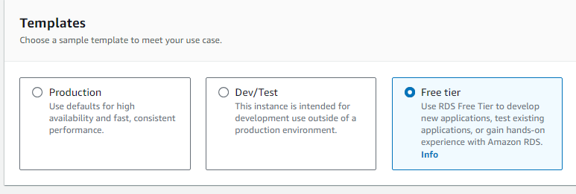

Now, provide the credentials as shown below and make sure to keep note of master username and password.

Choose the minimum storage allocation.

In Storage Autoscaling, You can either go with enabled or disabled based on your preference.

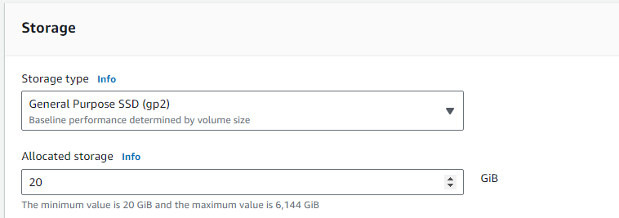

In Connectivity, Choose the options as shown below. Make sure you choose Public Access as No as the database is meant to be private.

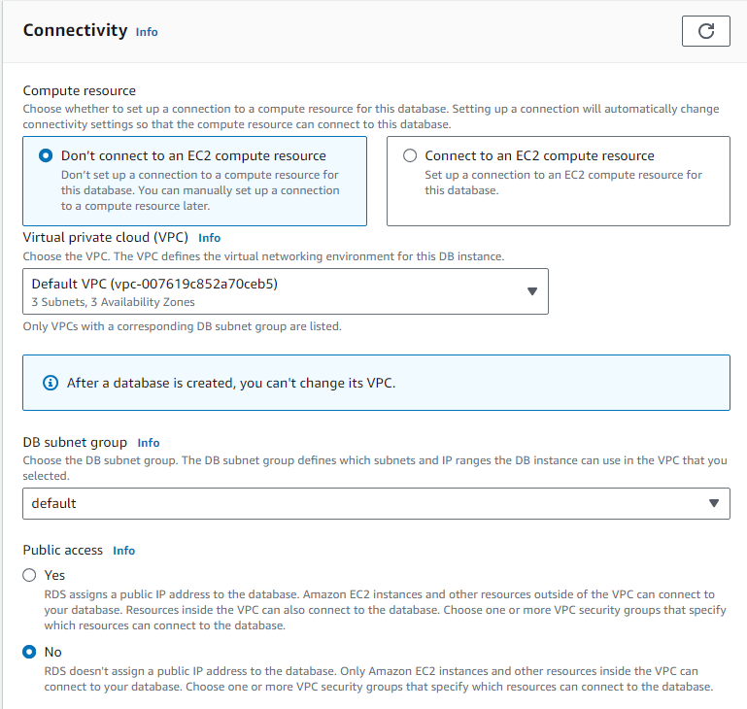

Create a new security group and provide a name, it will create a rule allowing necessary inbound traffic to this database through port 3306 ( MySQL/Aurora).

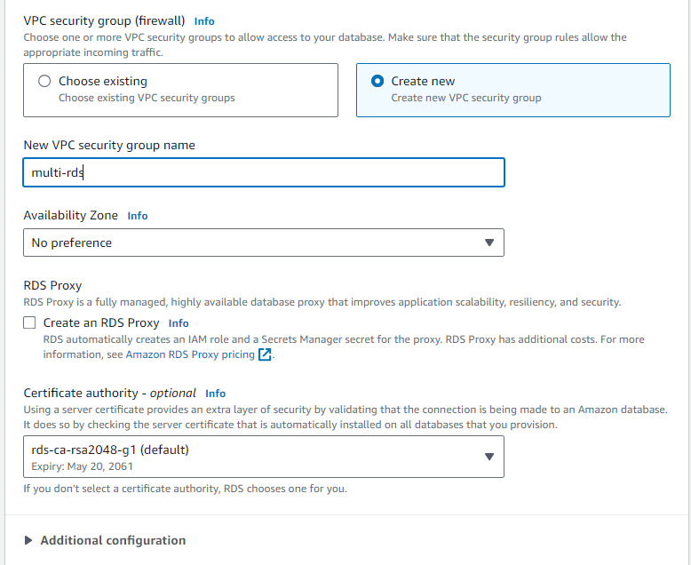

In Additional Configuration, provide the initial database name as per the problem statement

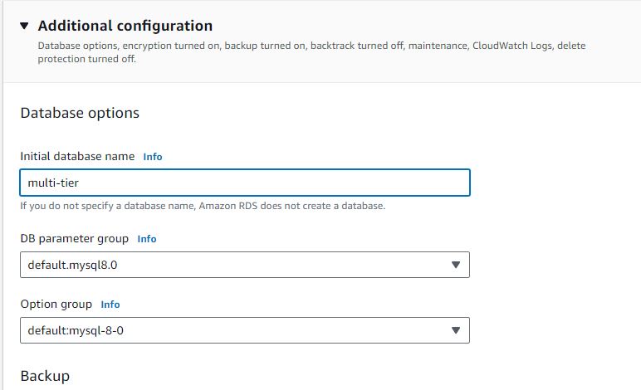

Wait for a few minutes until RDS Instance is created.

Note down the RDS Endpoint and port, as we will need it later on while connecting our EC2 server with this database.

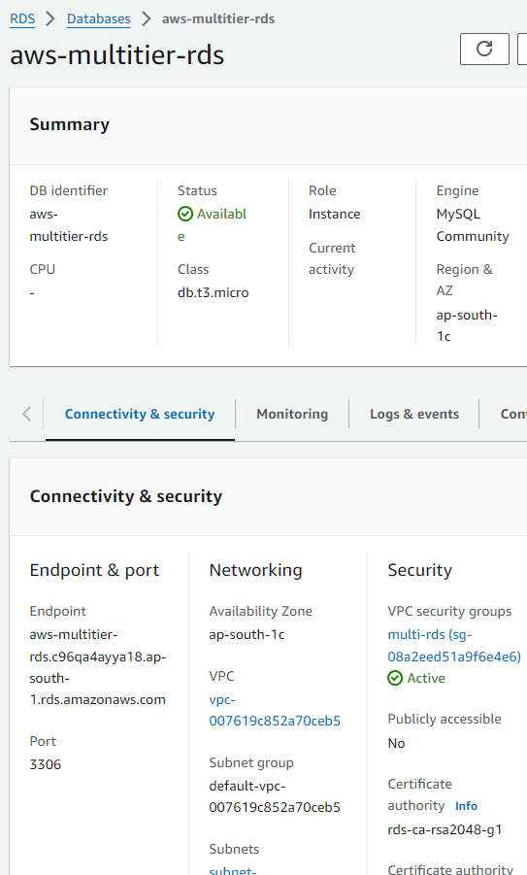

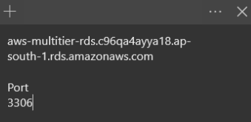

Now, Click on Project1-RDS-Sg, as we will need to modify its inbound rules to allow necessary traffic.

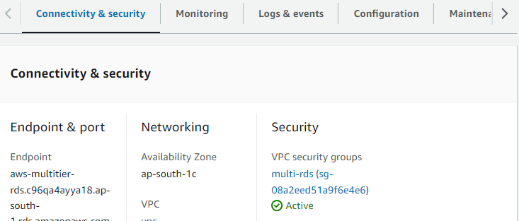

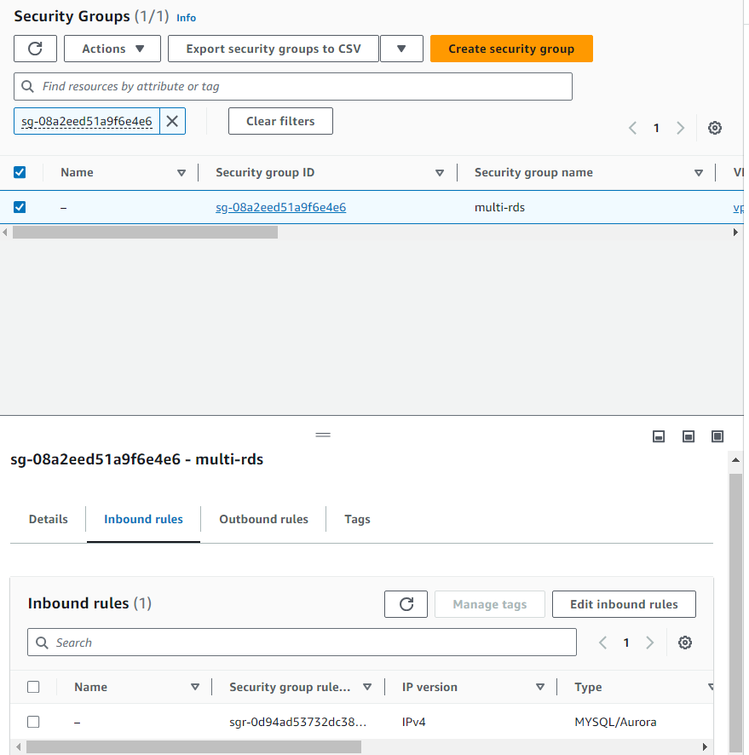

Here, you can see the connections are allowed from a certain IP. This can become a bottleneck later on if we have multiple servers with the same application that share the same database instance.

We will change this rule to allow all possible IP addresses.

Allow the traffic from source 0.0.0.0/0

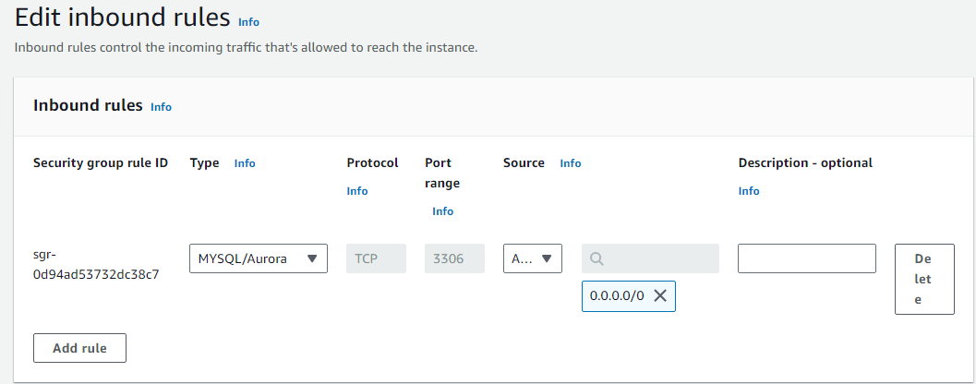

Now, let's head back to the EC2-server and install Mysql Packages that are compatible with our PHP application.

Import the repository and install the packages using the commands below:

*sudo add-apt-repository -y ppa:ondrej/php*

*sudo apt install php5.6 mysql-client php5.6-mysqli*

Now, we will connect with our RDS Instance and create a table in the database to store the user data coming through the application.

Copy the RDS endpoint and head back to the EC2 server.

Use the command as shown below.

Replace RDS endpoint, username credentials according to your RDS Instance.

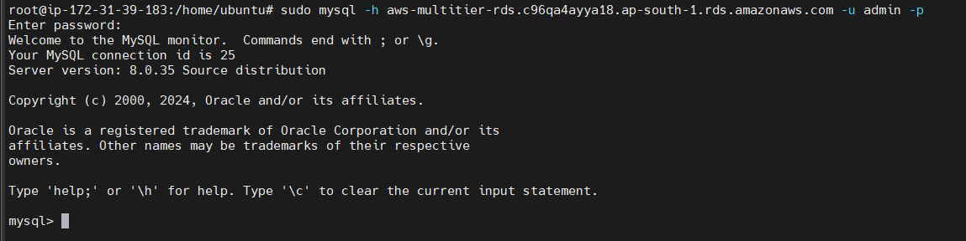

After connecting to the database, use the command below to list available databases:

*show databases;*

You can see the initial database available here:

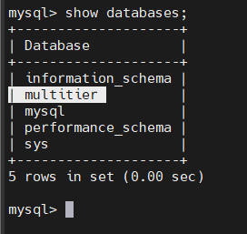

To change the database use the command below:

*use multitier;*

To create table use the command below:

*create table data(firstname varchar(21),email varchar(21));*

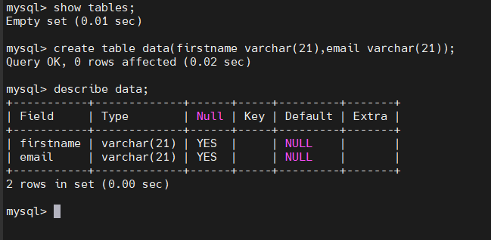

Table is created. Use exit to quit the Mysql shell.

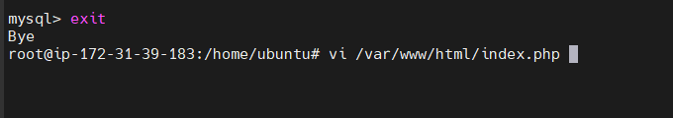

Now, it's time we integrate this database with our website.

Open the index.php file in the any editor.

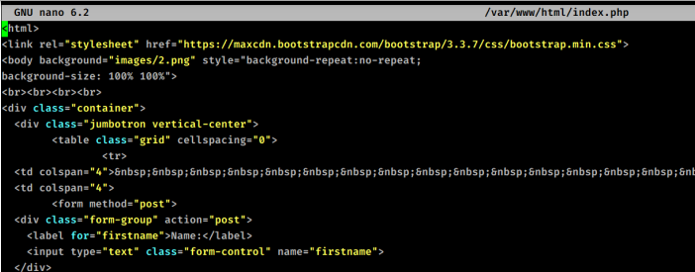

Scroll down to this line, where we need to update the database credentials. Update servername, username, password and database name.

Now, credentials are updated and it is now integrated with our RDS database.

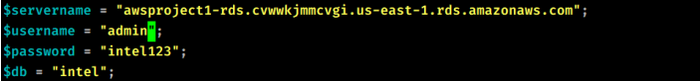

Now, refresh the page and you should be able to see that the console output which was showing an error is now rectified and now we are ready to use this application.

Provide the Name and Email and click on Submit

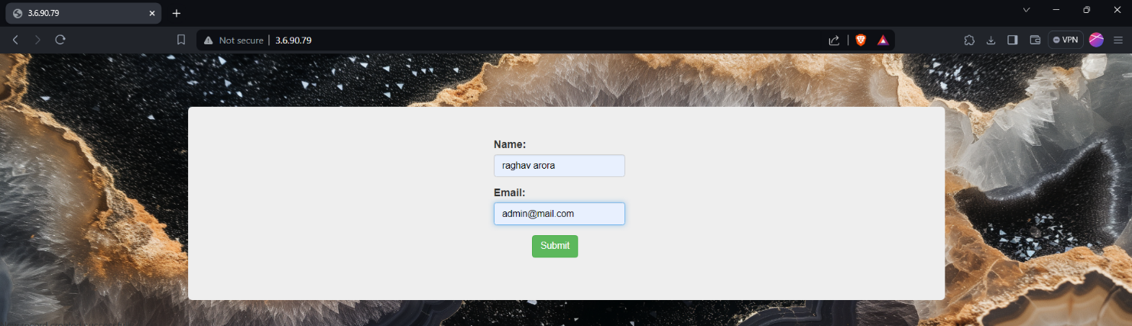

You’ll see a console output suggesting “New record updated successfully”.

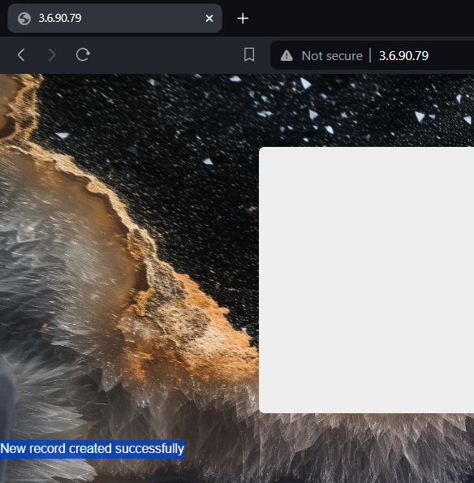

Now, lets connect to our MySQL database again and verify whether the database has new entries from the application.

Use the command below to list all the new row entries in the database.

*select * from data;*

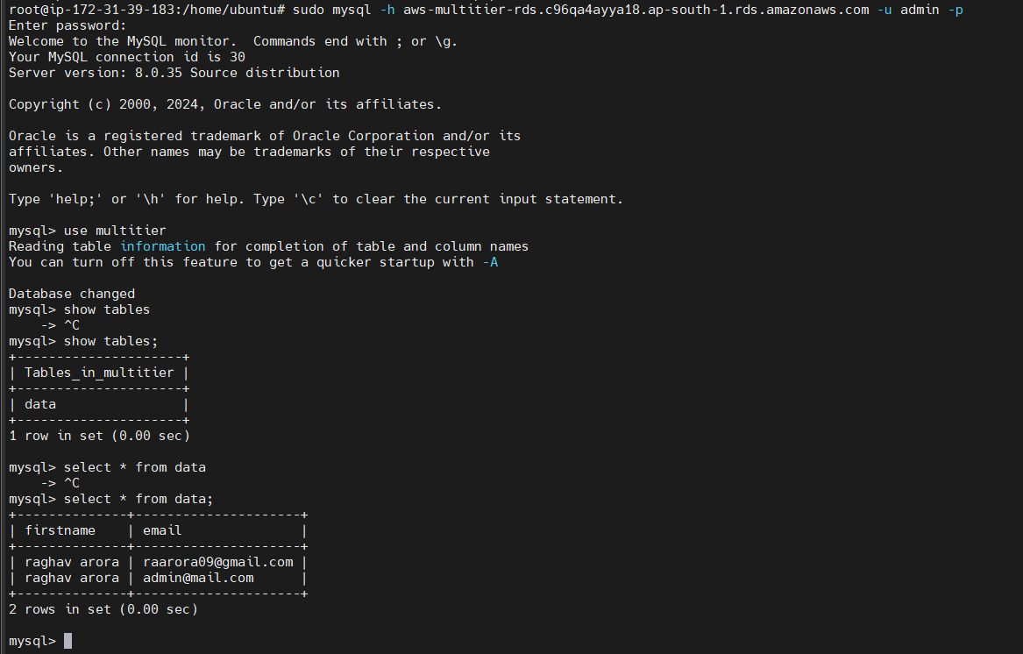

As you can see, the application is running successfully and we are able to store the data from the application.

Now, let's implement the Autoscaling for this application.

Choose the Instance and Click on Create Image in Actions-> Image and templates-> Create Image

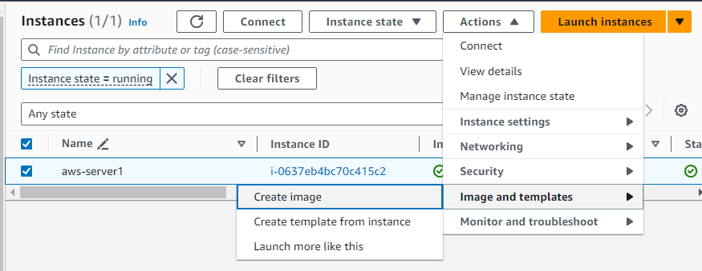

Provide a name and click on Create Image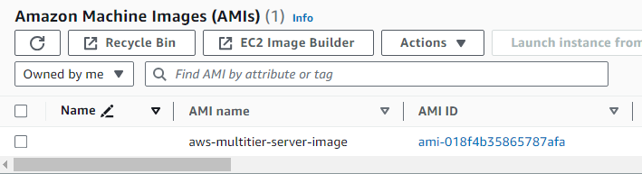

Now, we will use this AMI to create a Launch Template.

Select the EC2 Instance, Go to Actions, Images and Templates. Select Create Template from Instance.

Provide a Name to the template and in version description, you can provide main

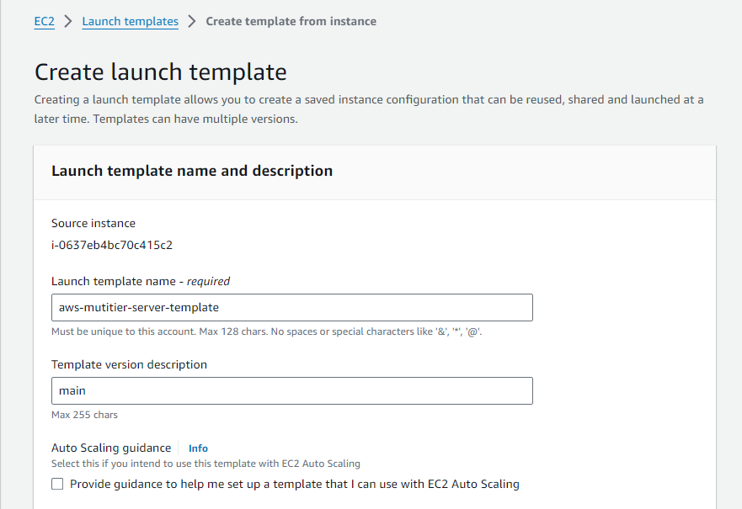

Now, When selecting AMI, go to My AMI’s and select the AMI that we created.

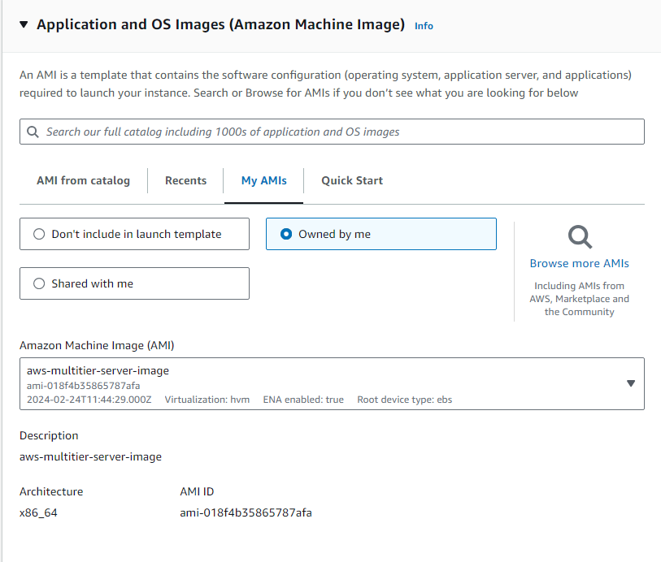

Launch Template is Created Successfully

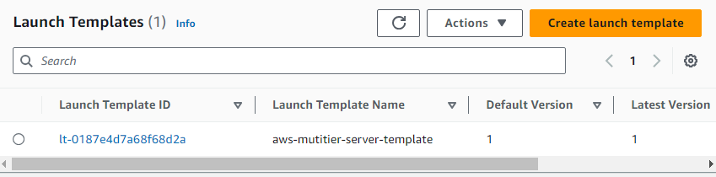

Now, let's create an Autoscaling Group using this Launch Template.

Provide a Name and select the Launch Template for Autoscaling group as shown below.

Click on Next.

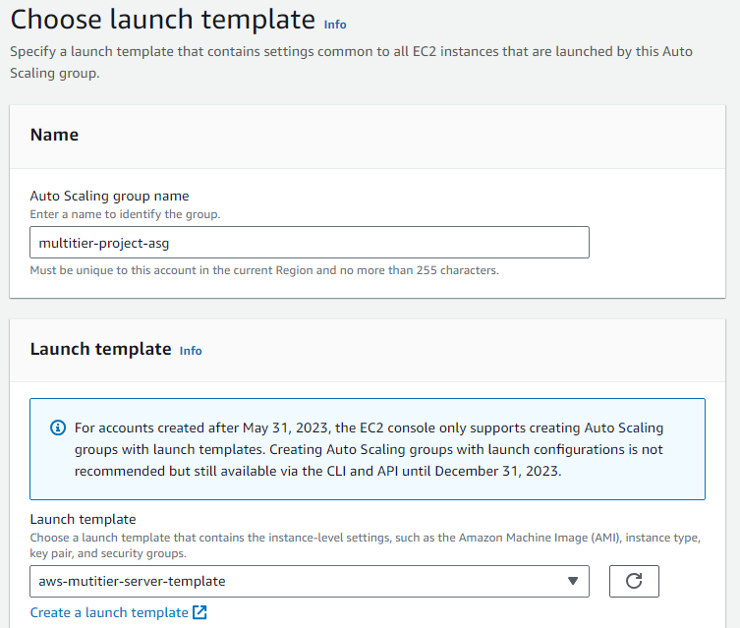

Select the VPC and minimum of two availability zones for high availability.

In this case I have selected all the availability zones available.

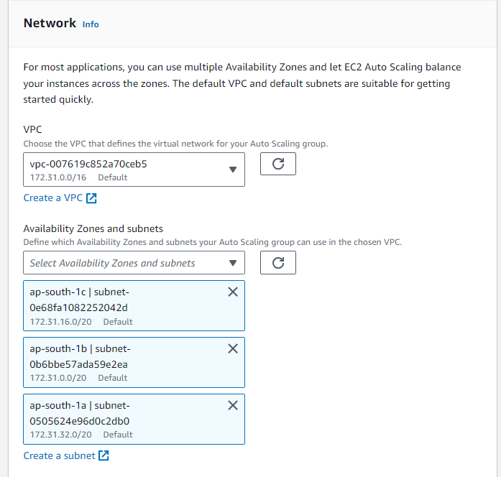

In load balancer, Choose No Load Balancer. Select the options as shown below.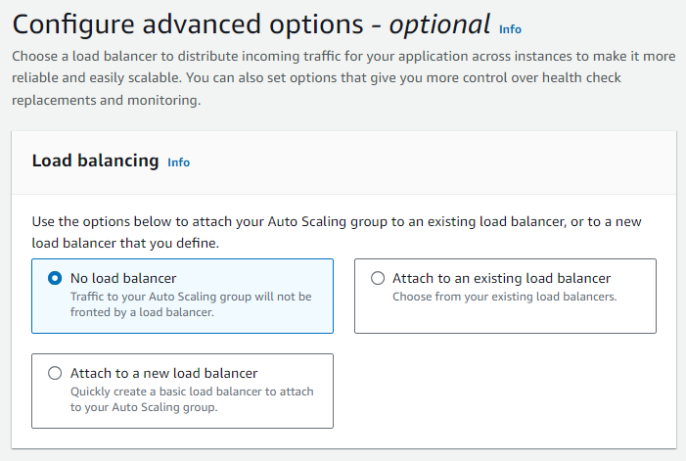

Choose the desired capacity in Group Size, in this case I have gone with 2,1 & 3.

So, This autoscaling group will create minimum of two EC2 Instances to start with.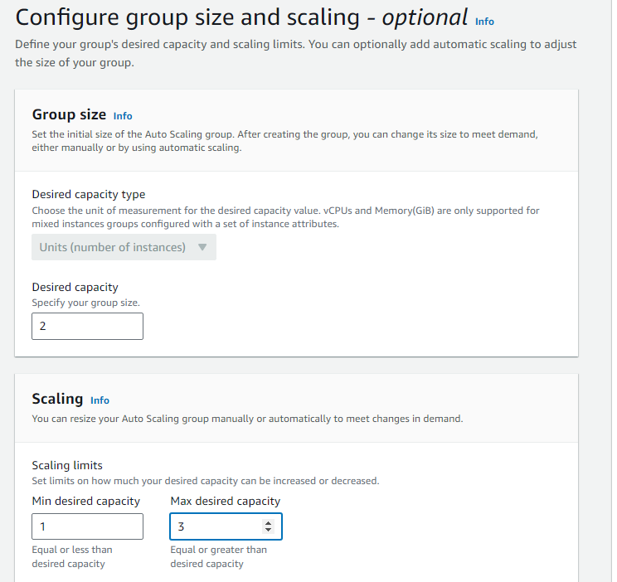

Notifications are optional, skip this and click on Next.

Tags are also optional, depending on whether you want to have tags on EC2 Instances created by Auto Scaling group.

Click on Next.

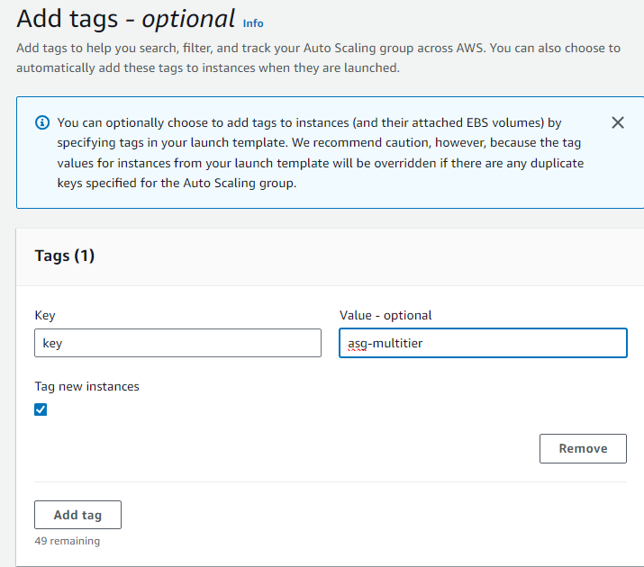

Review and Create Auto Scaling Group.

After creating Auto Scaling group, Go to Instances.

Here you should be able to see the newly created instances by Autoscaling Group

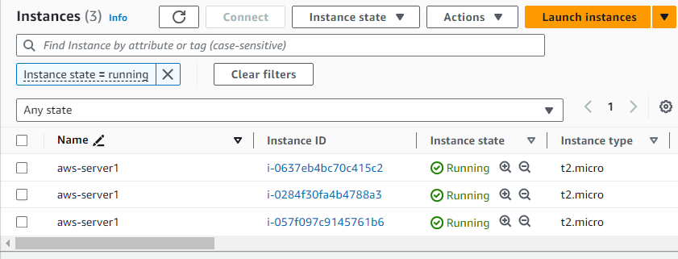

Copy and paste the public IP of any of the newly created servers in the browser and you should be able to see the application already up and running inside them.

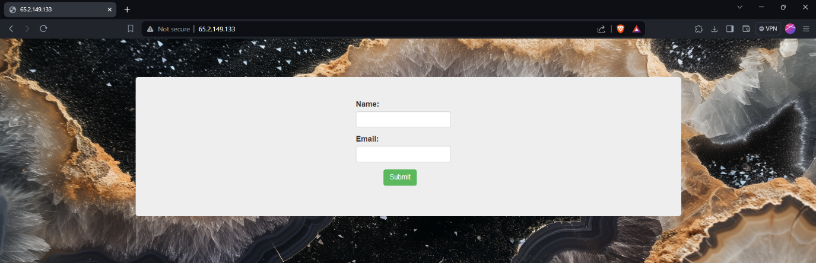

Note: To clean up all the resources provisioned, terminate the RDS Instance first, then Autoscaling Group, Launch Templates and AMI in the order followed up by the Initial EC2 Server we started with.

This Completes the tutorial for AWS Project - Deploying a Multi-tier Website using EC2.

Thanks.